BEST PRACTICES

1. **Public outreach activity**

**A. Vector borne disease**

* **Dengue**
* **Scrub typhus**
* **Lump skin disease**
* **Peoples are awared about vector borne disease.**

**B. Farmers training**

* **Apiculture and Sericulture**
* **Aquaculture**
* **Farmers are trained in both apiculture and aquaculture.**

**C. Heavy metal and cancer awareness**

* **Groundwater contamination**
* **Cancer awareness programme**

**2. Activity and Problem Based Learning**

A. Students has visited Pong Dam for identification of bird species and acquainted with identification tools

B. Students has visited costal area of Gujarat for identification of marine animal species

C. Students has visited Chhattbir Zoo, Zirakpur for identification of different species of wild animals

D. Students has Visited Manesher Lake for identification of zooplankton species on Wetland day.

**Through these visit students has learned about different animal species and species identification techniques.**

**Glimpses of Best Practices carried out by Department of Animal Science**

**A. Vector borne disease**

Awareness program was organized at Government Senior Secondary School Banikhet, Chamba, and Government Senior Secondary School Dalhousie, Chamba under DHR sponsored project in association with Monal Club, Department of Animal Science, Central University of Himachal Pradesh on 05/11/2022. The awareness among students was created regarding scrub typhus and zoonotic disease.

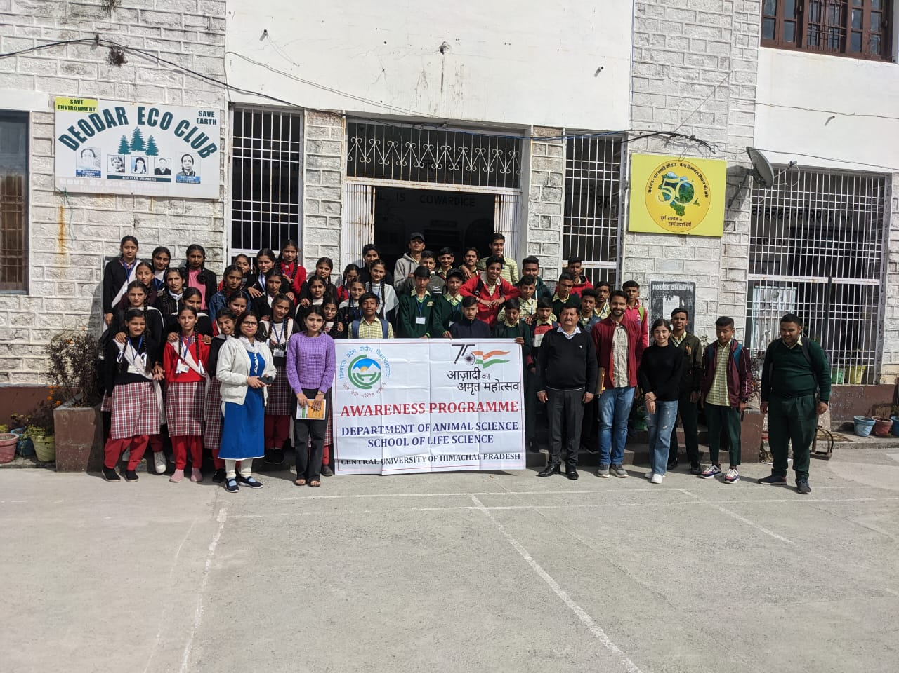

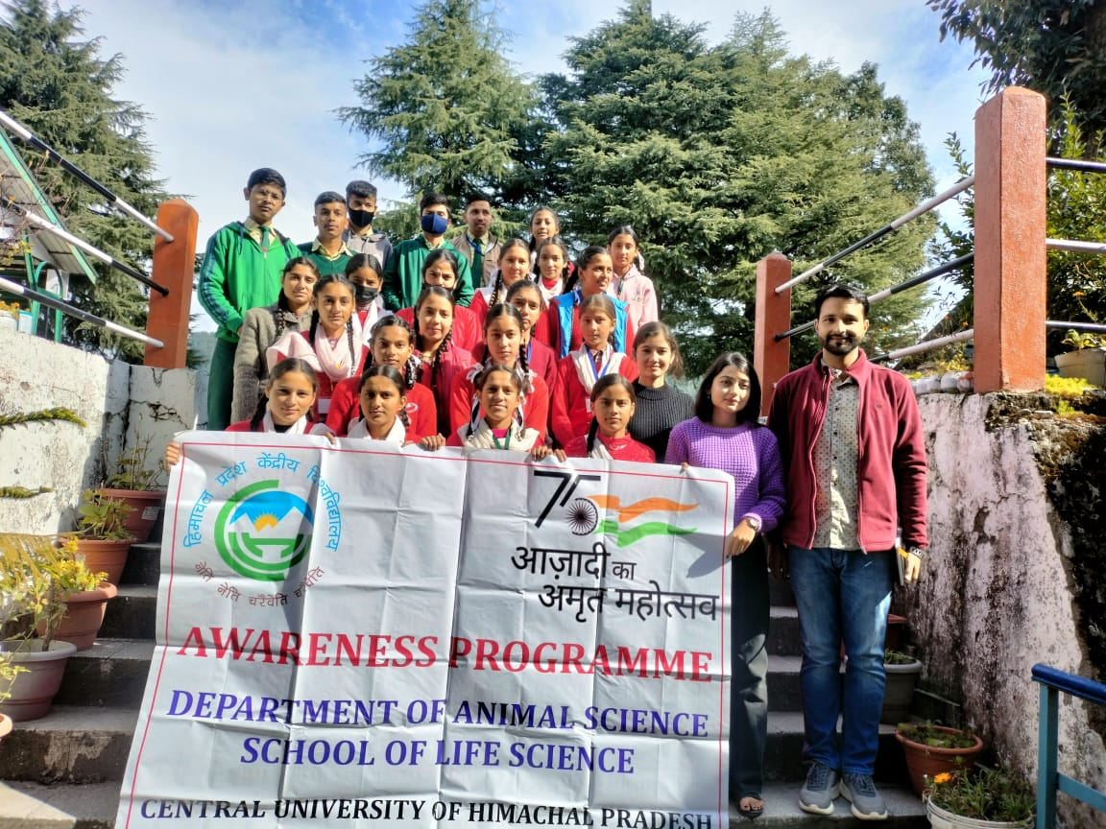

Awareness program was organized at Government Boys' Senior Secondary School, Chamba, Government Girls' Senior Secondary School, Chamba and Government Senior Secondary School, Khajjiar under DHR sponsored project in association with Monal Club, Department of Animal Science, Central University of Himachal Pradesh on 15/10/2022. The awareness among students was created regarding scrub typhus, zoonotic diseases, Lumpy skin disease and other neglected diseases prevalent in North Western Himalayan Region.

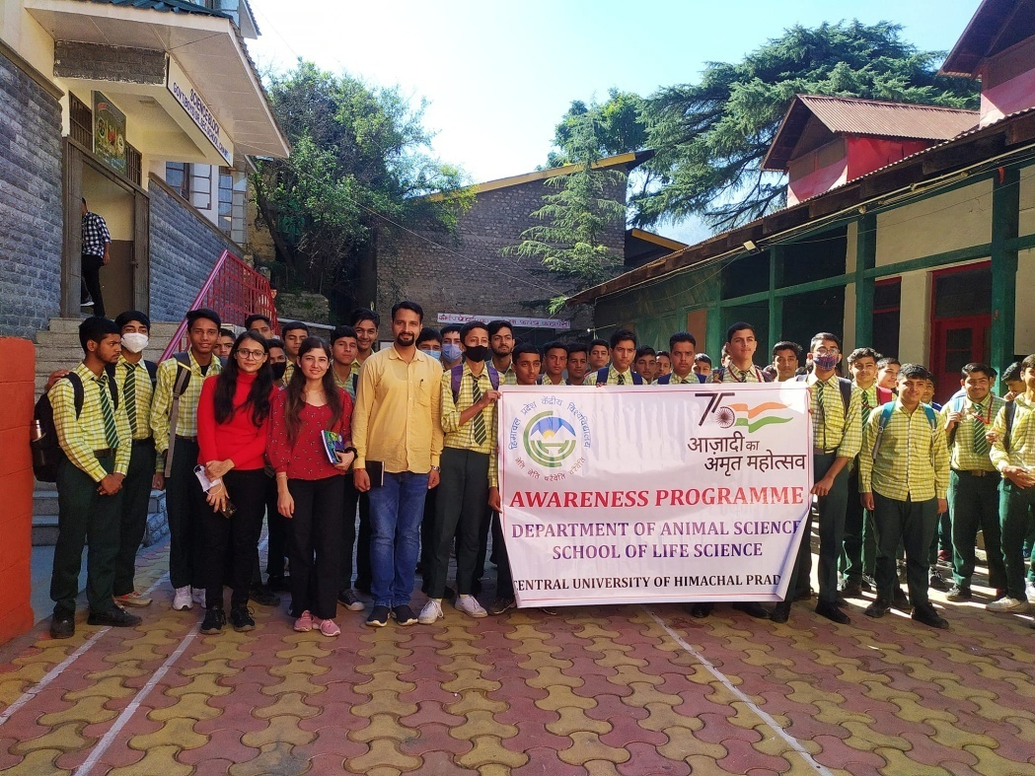

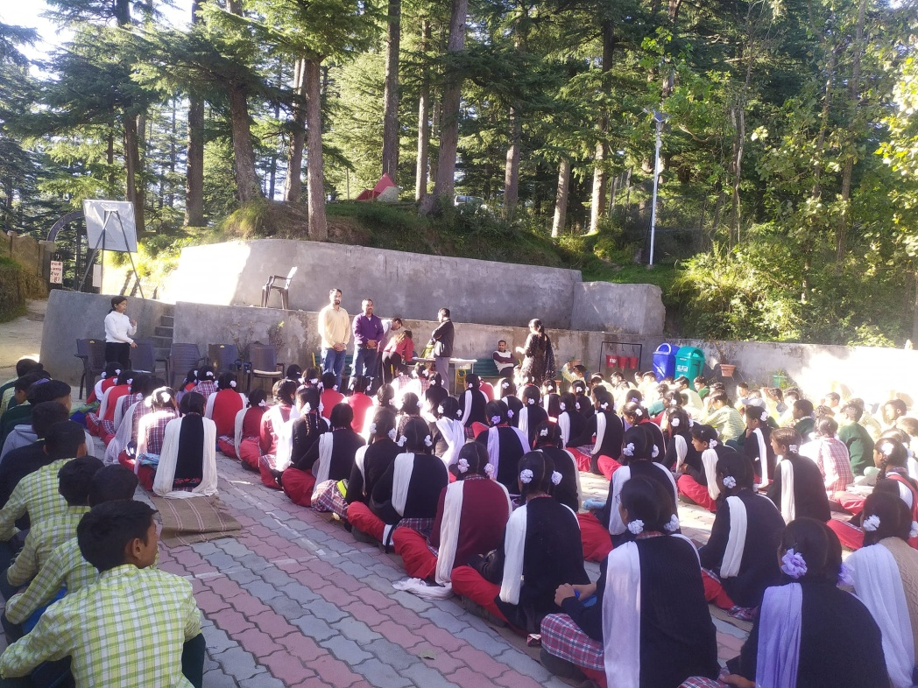

**B. Farmers training**

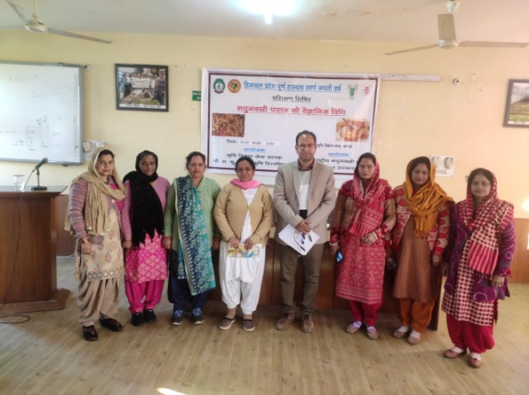

**Figure-1: Farmers are trained for apiculture on 14 – 20 February 2022 at Kangra. It will help rural community of the state in self employment.**

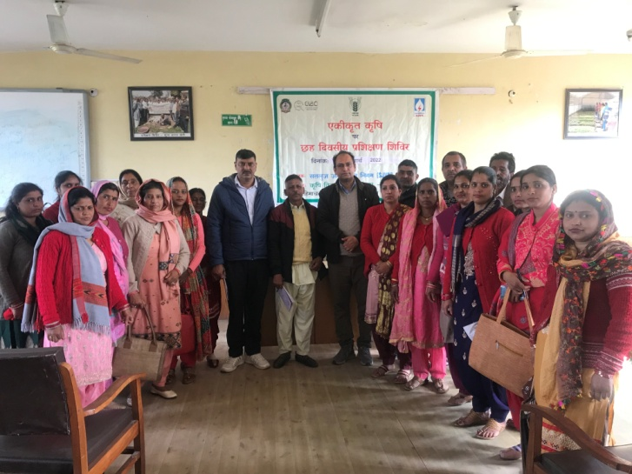

**Figure -2: Training for farmers in March 2022 in association with KVK. This is six days training programme for development of agriculture skill in farmers.**

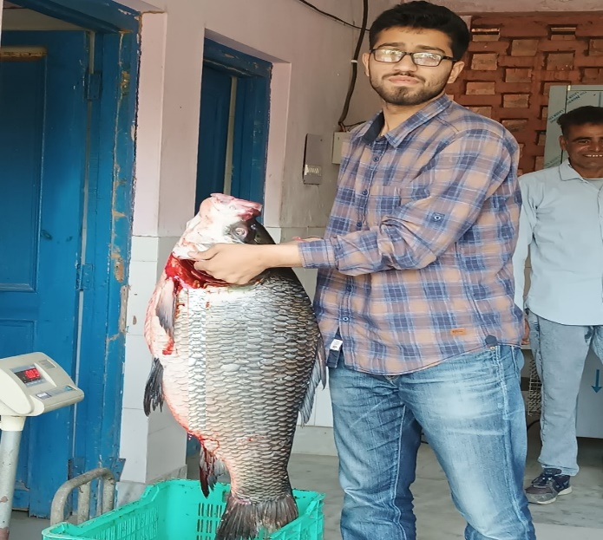

A visit to Fisheries landing centre Guglara

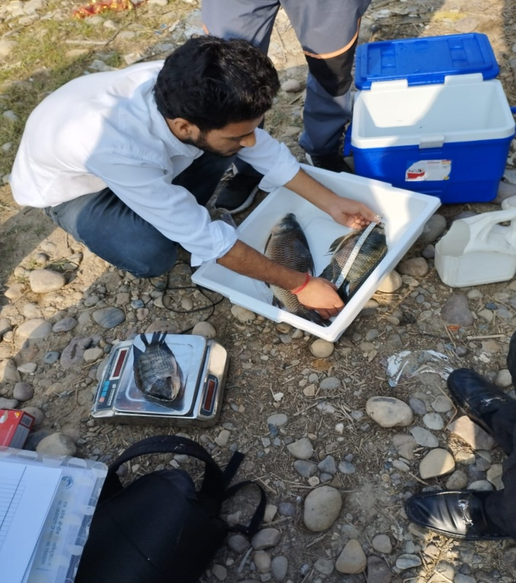

Onsite Biometric analysis of fish sample in Pong reservoir near Jawali

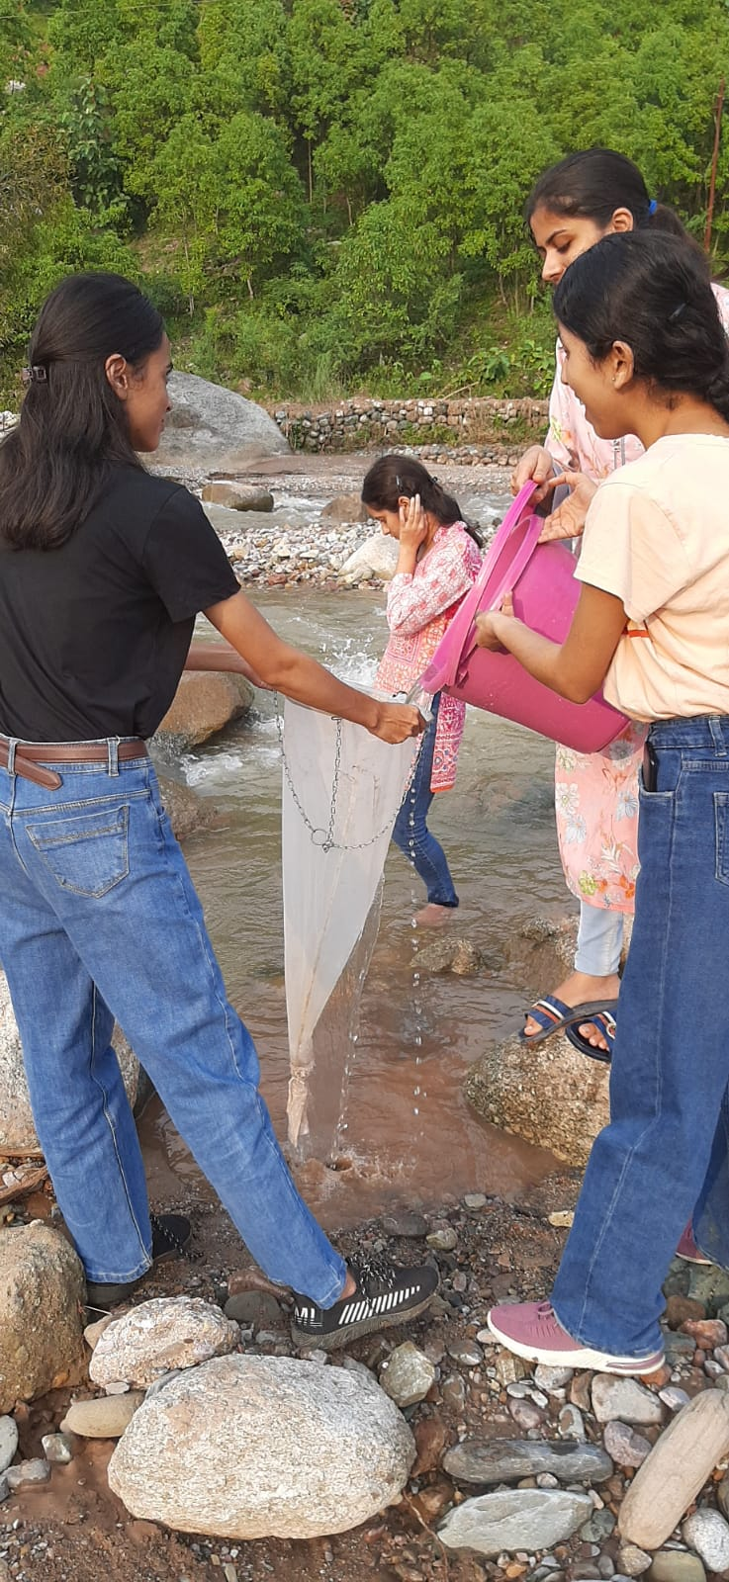

Plankton collection from Deharkhad near Draman

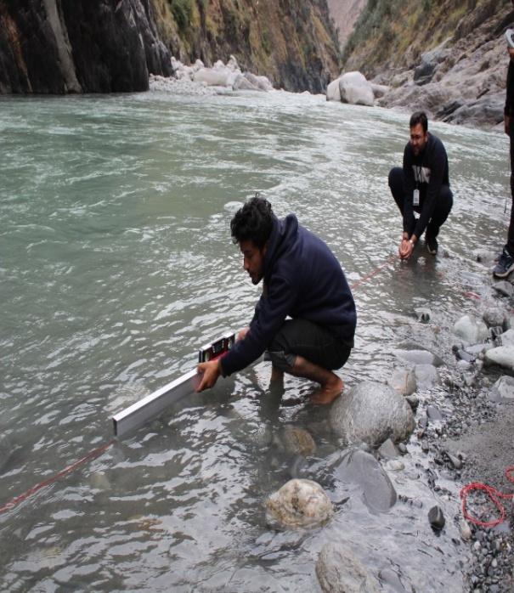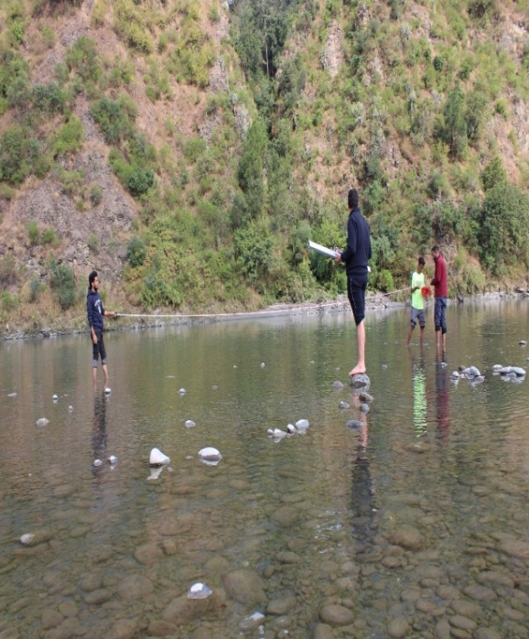

Slope Analysis of Ravi river near Garola and Saru (Chamba)

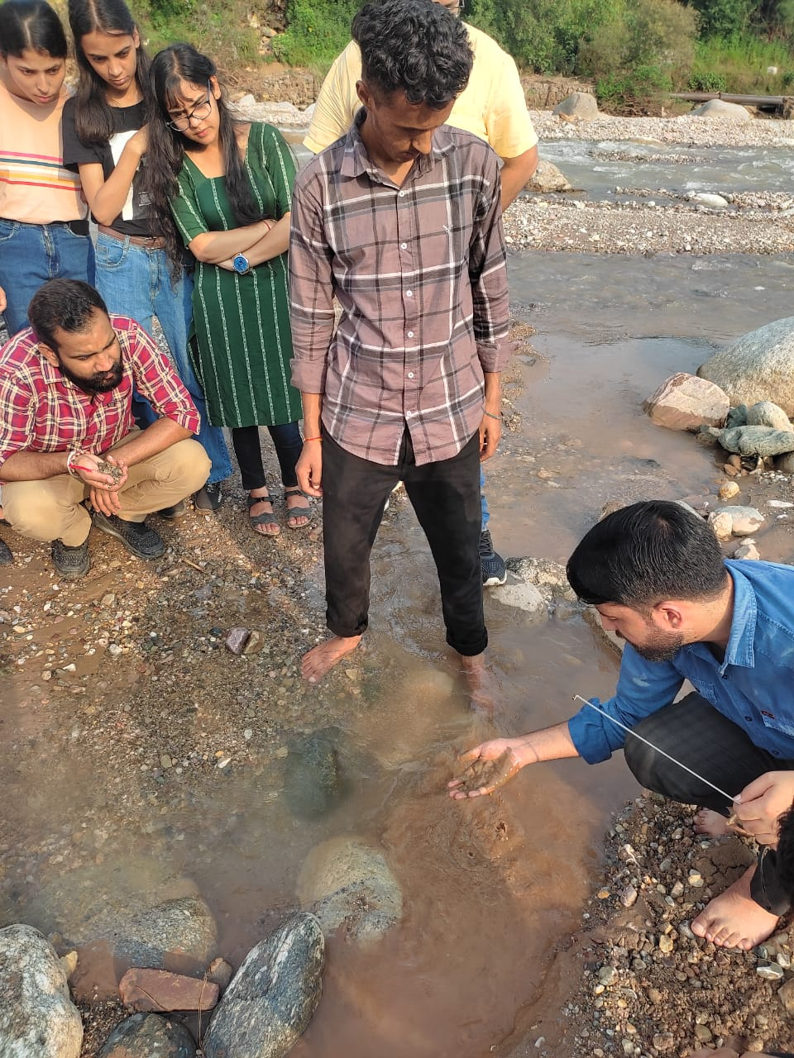

Sediment sampling for heavy metal analysis from Gajkhad

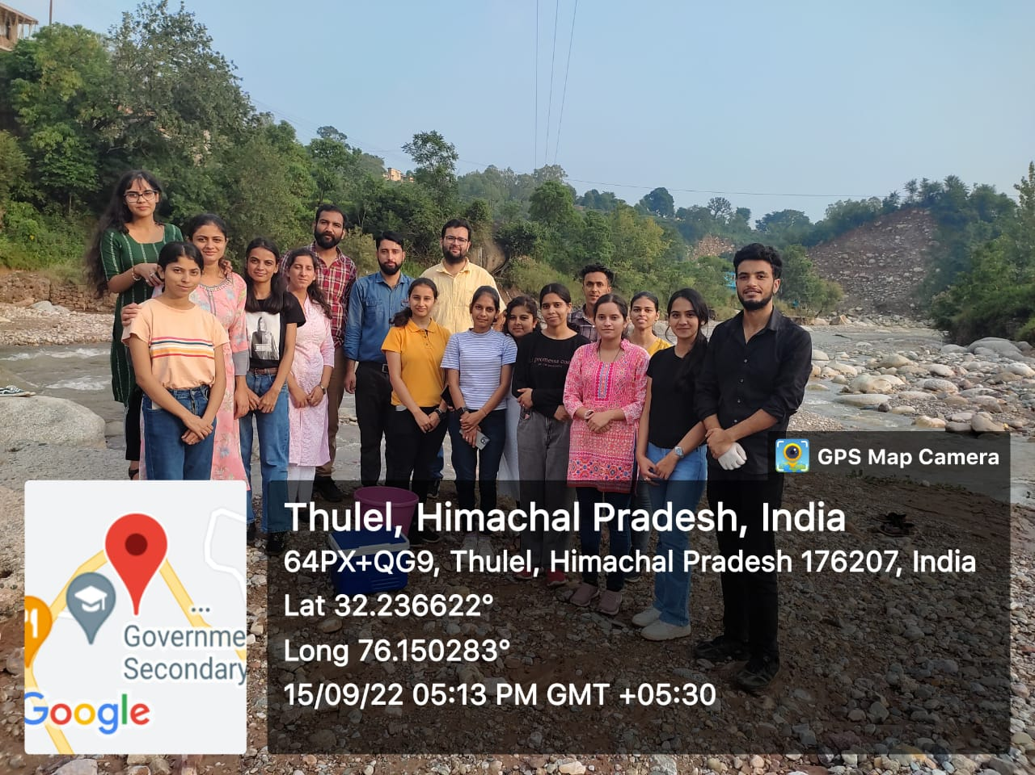

A visit for hydrological analysis of DeharKhad

**C. Heavy metal and cancer awareness**

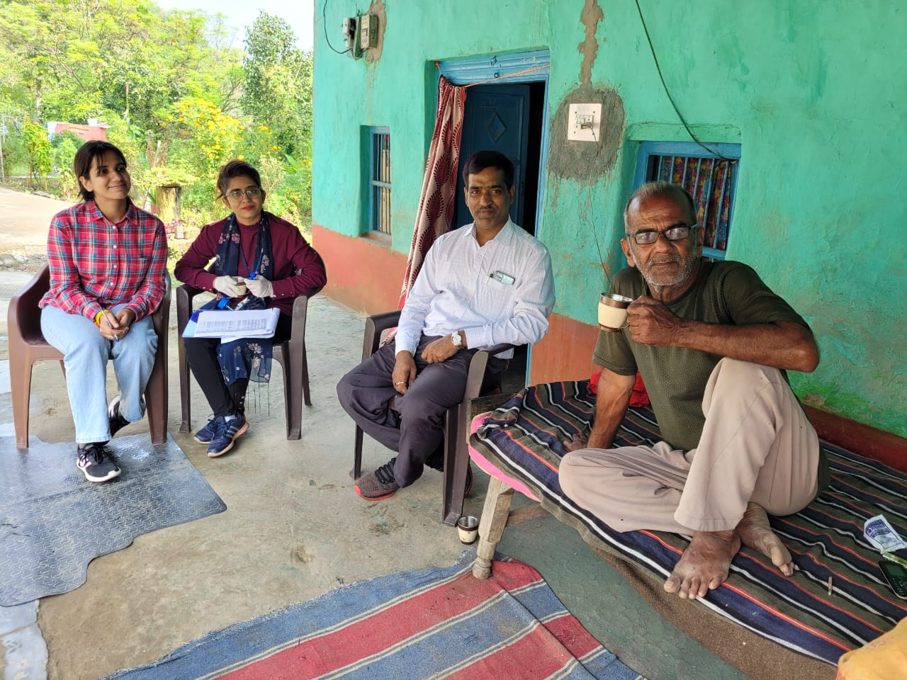

Field visit was done with our team in Khundian tehsil of district Kangra, H.P. We did a questionnaire survey with people on arsenic related health symptoms.

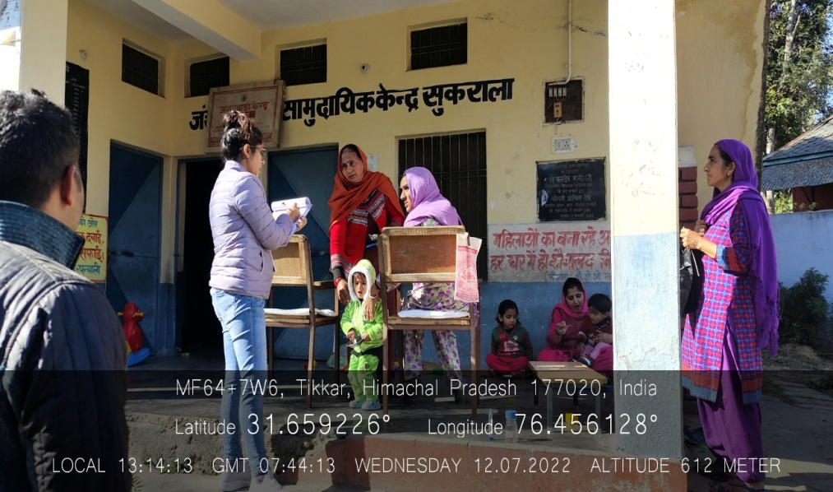

Field visit was done in village Sukralaof district Hamirpur, H.P. A questionnaire survey was done with peopleon arsenic related health symptoms.

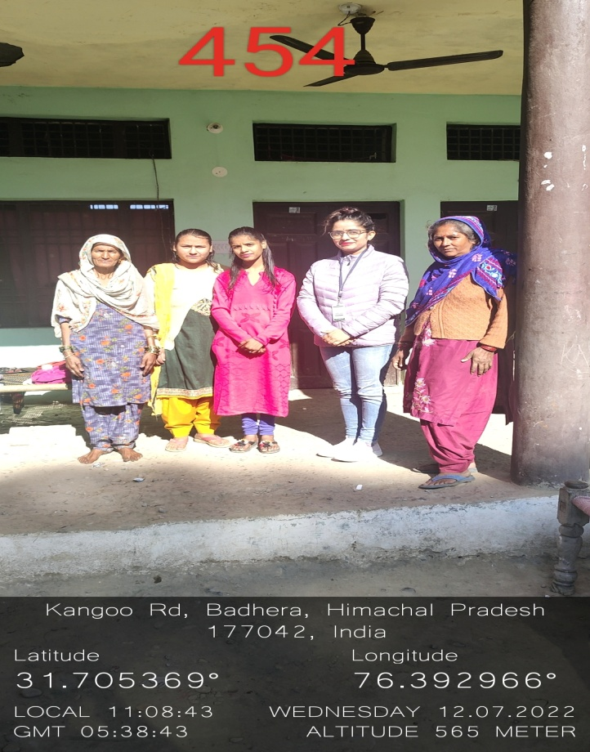

Field visit was done in tehsil Kangooof district Hamirpur, H.P. A questionnaire survey was done with peopleon arsenic related health symptoms.

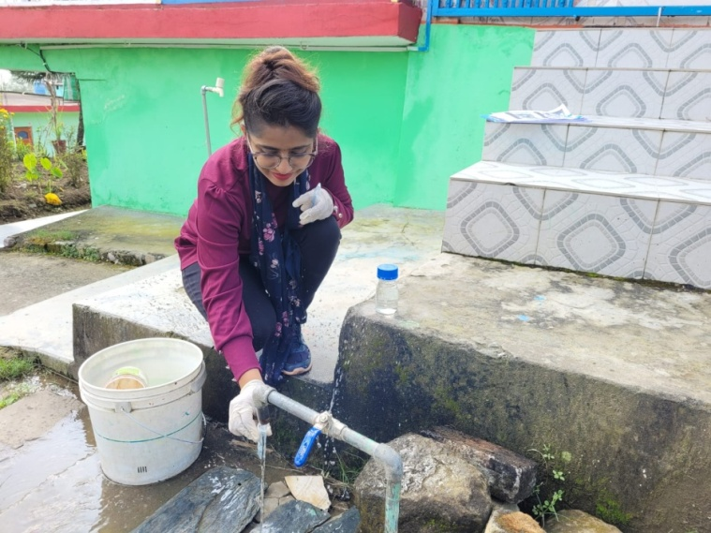

Field visit was done in Khundian tehsil of district Kangra,, H.P for collection, and analysis of groundwater samples for pH, TDS and arsenic levels.

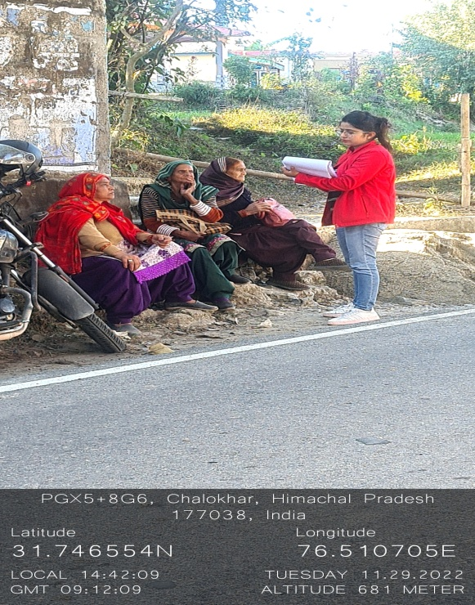

Field visit was done in tehsil Sujanpurof district Hamirpur, H.P. A questionnaire survey was done with peopleon arsenic related health symptoms.

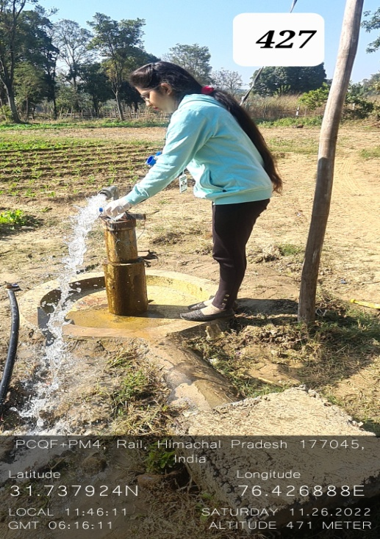

Field visit was done in Chorku village of tehsil Nadaun district Hamirpur, H.P for collection, and analysis of groundwater samples for pH, TDS, and arsenic levels.

**2. Activity and Problem Based Learning**

A. Students has visited Pong Dam for identification of bird species and acquainted with identification tools

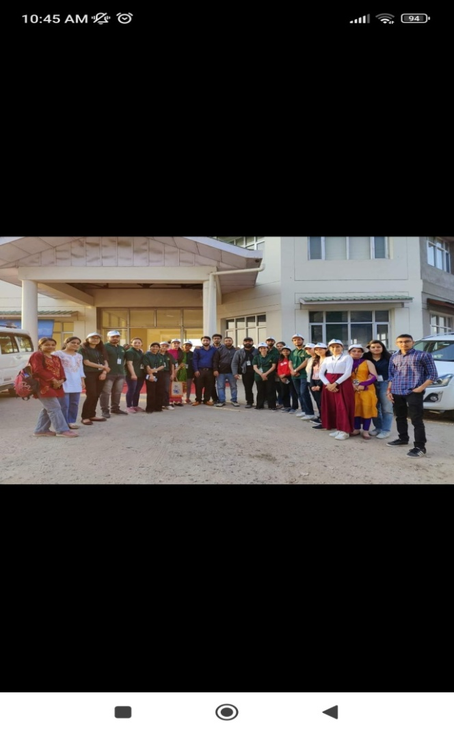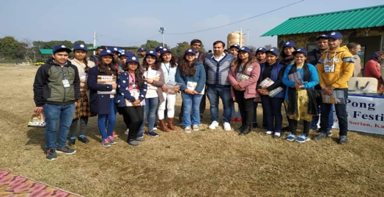

B. Students has visited costal area of Gujarat for identification of marine animal species

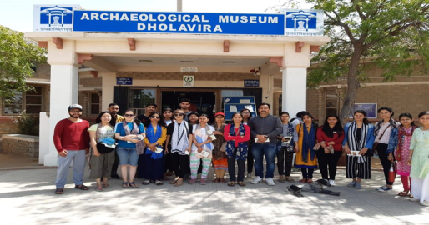

C. Students has visited Chhattbir Zoo, Zirakpur for identification of different species of wild animals

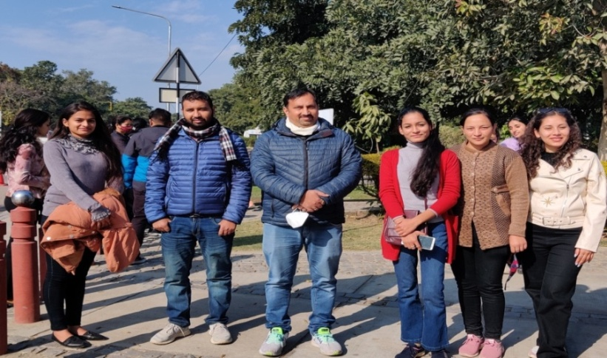

D. Students has Visited Manesher Lake for identification of zooplankton and Fish species on Wetland day.

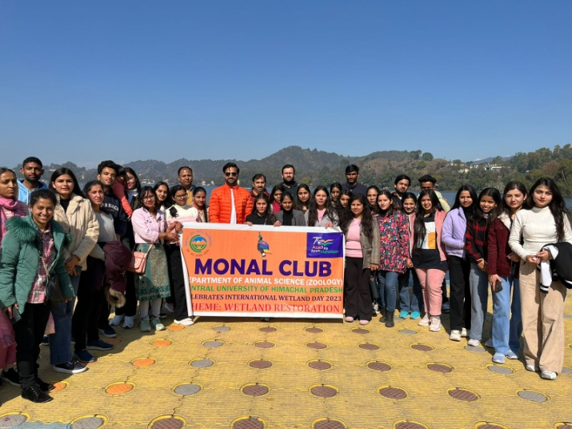

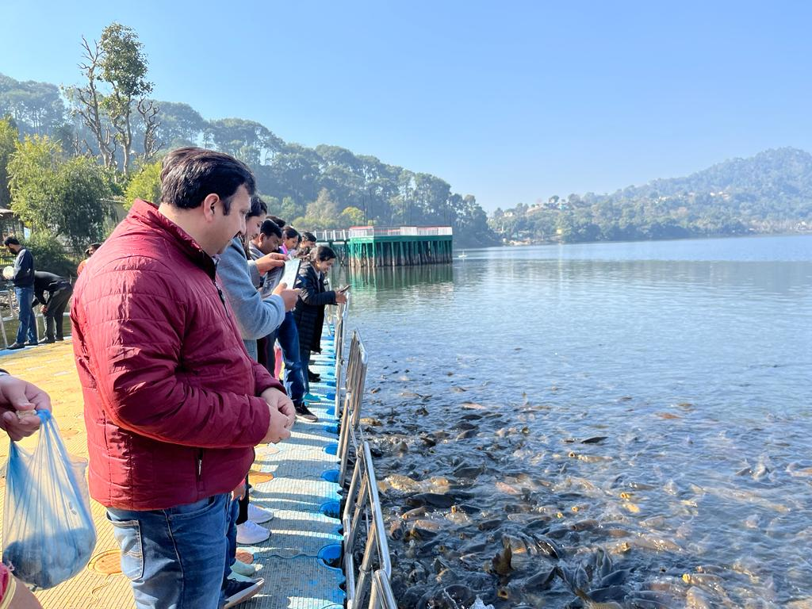

**Through these visit students has learned about different animal species and species identification techniques.**