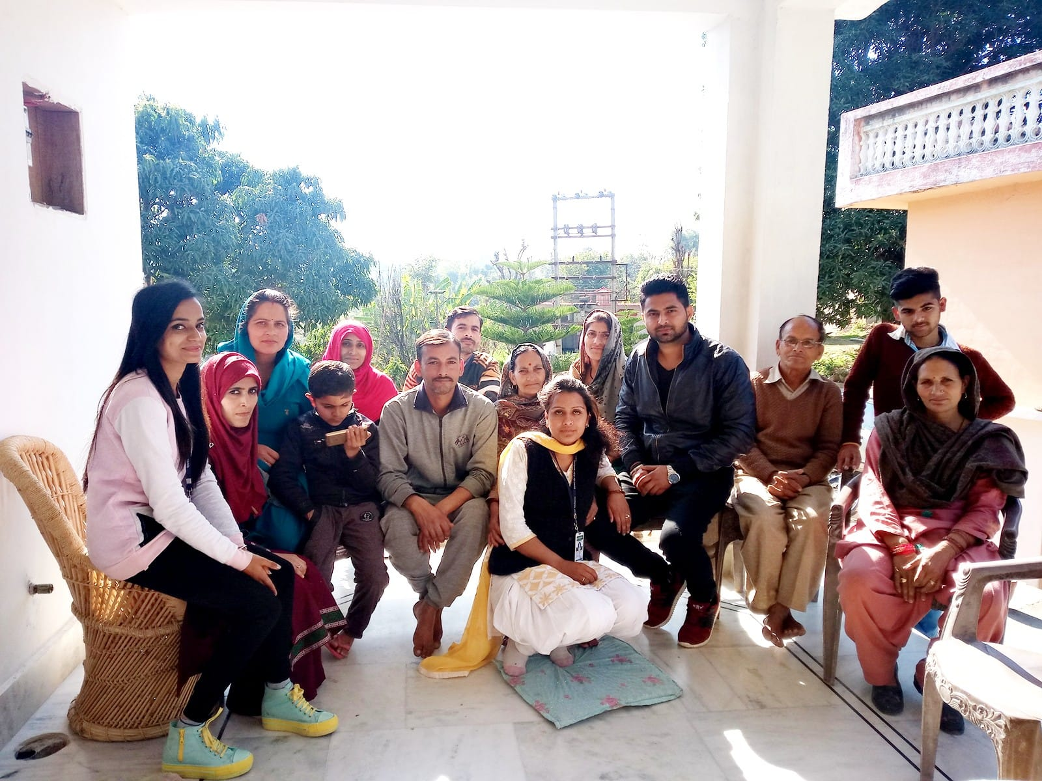**Winter Rural Camp in Communities, in Collaboration with Central University of Jammu February 2018.**

**Winter Rural Camp in Communities, in Collaboration with Central University of Jammu**

A three-day long Winter Rural Camp in collaboration with Central University of Jammu along with Department of Social Work, Central University of Himachal Pradesh from 13-02-2018 to 16-02-2018. 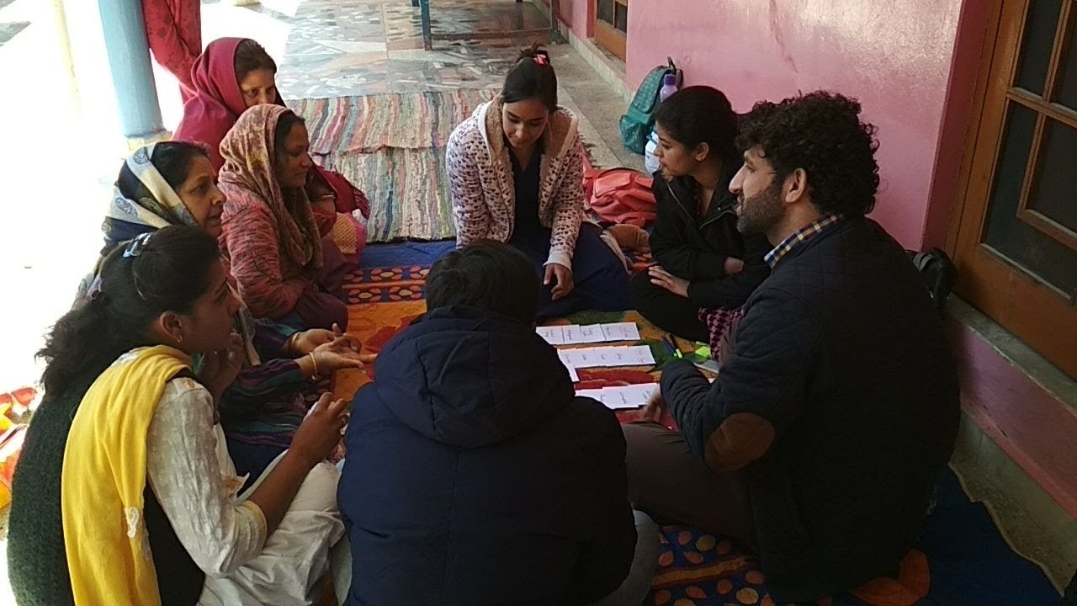

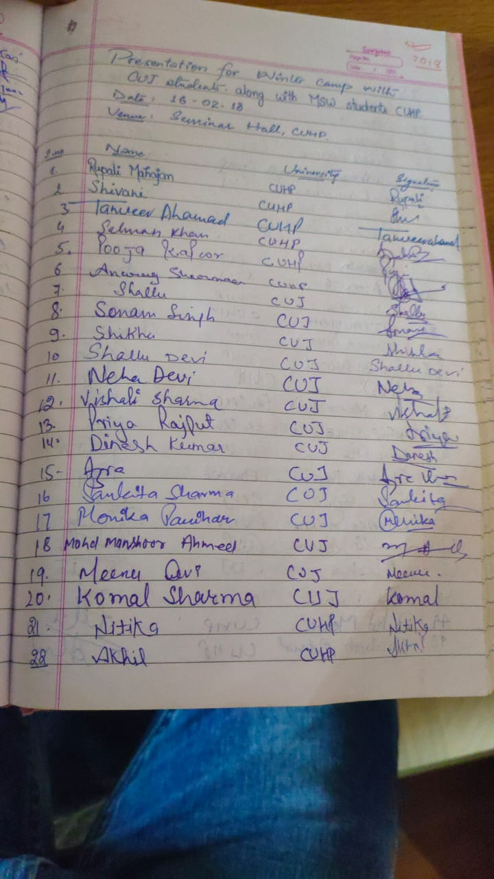

**International Women Day Celebration**

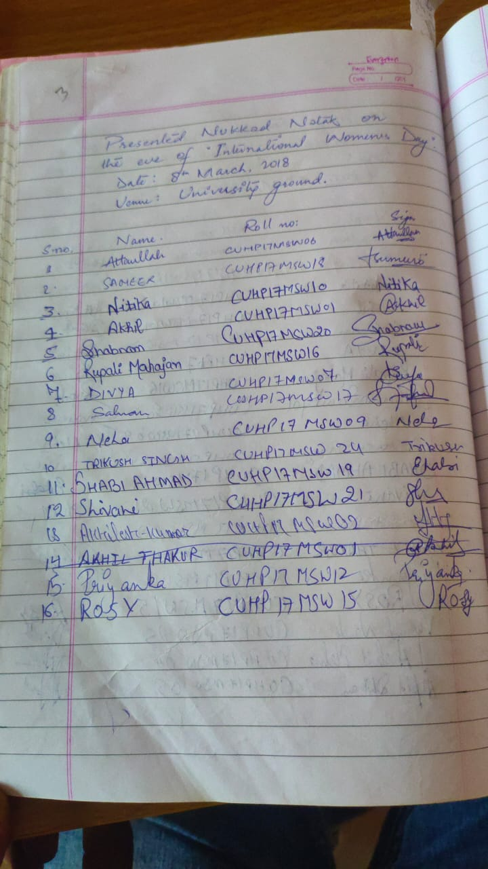Students of MSW IInd semester presented a Nukkkad Natak as part of International Women Day celebration on 08th March 2018 at T.A.B. Central University of Himachal Pradesh, Dhauladhar Parisar.

**Youth LeadershipTraining Programme**

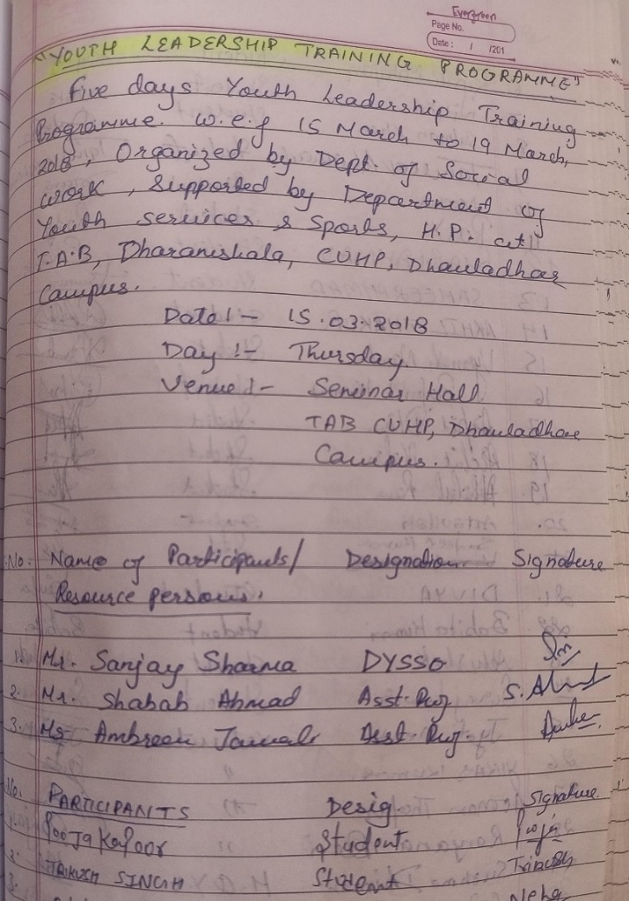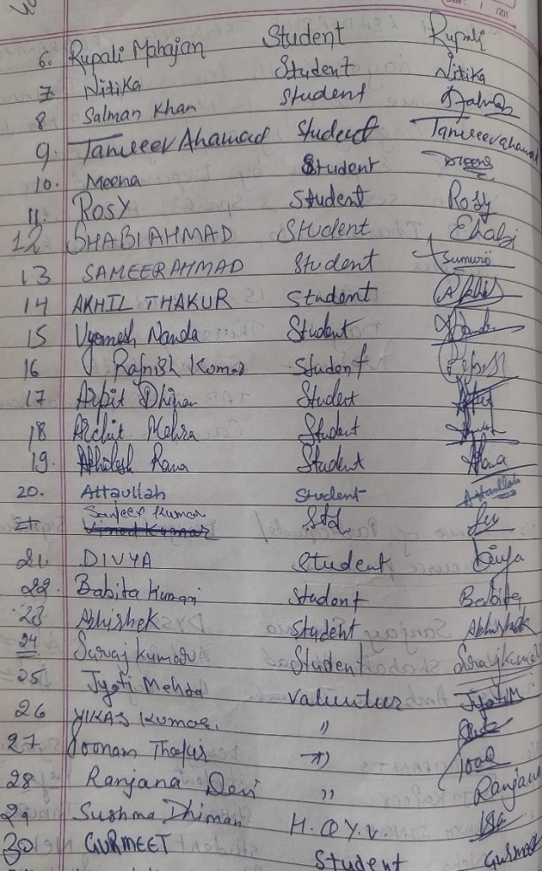Five days Youth Leadership Training Programme, w.e.f. 15th March to 19th March 2018 organized by the Department of Social Work supported by Department of Youth Services & Sports, H.P. at T.A.B. Dharamshala, Central University of Himachal Pradesh, Dhauladhar campus. Youths from all over the Kangra districts participated in this leadership development program. The learning (such as leadership, conflict management, from these camps

